Case 1-Eur-Czech Rep-Petřkovice, Female Figure-Venus-Gravettian-23 kya

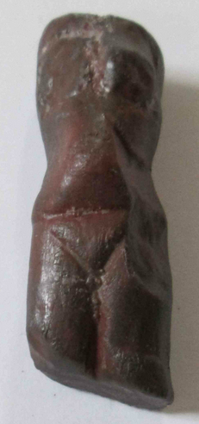 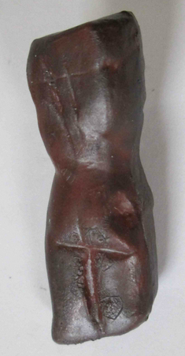

**Case No.:**

**Accession Number:**

**Formal Label:**

**Display Description:**

The Venus of Petřkovice (Czech: Petřkovická venuše or Landecká venuše) is a Venus figurine, a mineral statuette of a nude female figure, dated to about 23 kya (Gravettian industry).It is a headless torso of a body of a woman carved from hematite. Uniquely, the absence of the head appears to be the author's intention. Also, unlike other prehistoric Venus figurines, it shows a slender young woman or girl with small breast.

**LC Classification:**

**Date or Time Horizon:**

**Geographical Area:** within the current city limits of Ostrava (Ostrava-Petřkovice), Silesia, the Czech Republic

**Map:**

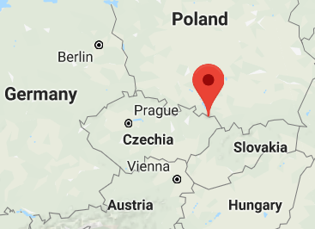 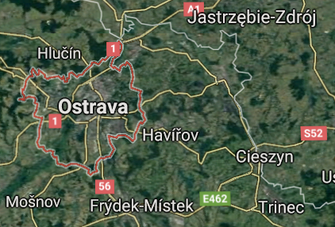

**GPS Coordinates:**

**Cultural Affiliation:**

**Medium:** hematite

**Dimensions:** The statue measures 4.5 x 1.5 x 1.4 cm **Weight:**

**Provenance:** It was found by archaeologist Bohuslav Klima on 14 July 1953. It was found beneath a mammoth molar at the ancient settlement of mammoth hunters. Many stone artifacts and skeletal fragments were found nearby.

**Condition:** professional cast resin replica of venus from Petřkovice, Silesia, CZ, EU. The original is now in the Archeological Institute, Brno.

**Discussion:**

**References:**

Leslie G. Freeman (ed.), Views of the Past: Essays in Old World Prehistory and Paleanthropology, Mounton Publishers, 1978